
PROSPEROUS ENCLAVE PHASE: ELECTRONIC CITY
Prosperous Enclave: An Overview

Prosperous Enclave with its close proximity to Electronics City, the IT Hub of Bangalore, makes it a perfect backdrop to the Silicon Valley of Bangalore. The green canopied layout with its wide black top roads adjacent to Vibgyor High School is a refreshing sight, away but yet near the city life. you leave behind the stressful city lifestyle. The refreshingly beautiful layout is situated just behind Wipro company and is in close proximity to many well-known IT Companies of the world. Leaving the children to school or attending to the office will be within your walkable reach away from the maddening traffic woes of Bangalore.
Prosperous Enclave Phase 1 and 2: Prosperous Enclave Phase 1 with 5 acres and 72 sites and Phase 2 with 2 acres and 38 are fully sold out. Houses have been constructed in the layout.

Prosperous Enclave Phase 3: Prosperous Enclave Phase 3 of 2.2 acres and 40 sites are open to sale now.

Prosperous Enclave: Location Highlights
- Rapid pace development.
- Surrounded by many International schools.
- Close to hospitals like Jayadeva, Narayana Hridalya, and Apollo.
- Proximity to Hosur Road, Bannergatta Road, NICE Road, Electronic City, Koramangala, Dairy Circle, HSR Layout, Sarjapur Road.
- 6 kms from Silk Board Madivala
- 10 mins drive from Sarjapur road.
- Adjacent to Vibgyor High School.
Prosperous Enclave: Project Specifications
- Drainage.
- Sanitary.
- Electricity with Street Lights.
- Black top road.
- Kids Park and play area.
- All round compound wall and round the clock security.
Prosperous: Area and Cost: Rs 1999/- Per Sq Ft
Prosperous Enclave: Project Payment Plan

- On booking: Rs. 1,00,000/-.
- Within the next 15 days: 30% of the total value.
- On registration: Remaining amount.
Home Loan
Housing loan available through Canfin Homes.

Prosperous Enclave : VIBGYOR HIGH School at the Background

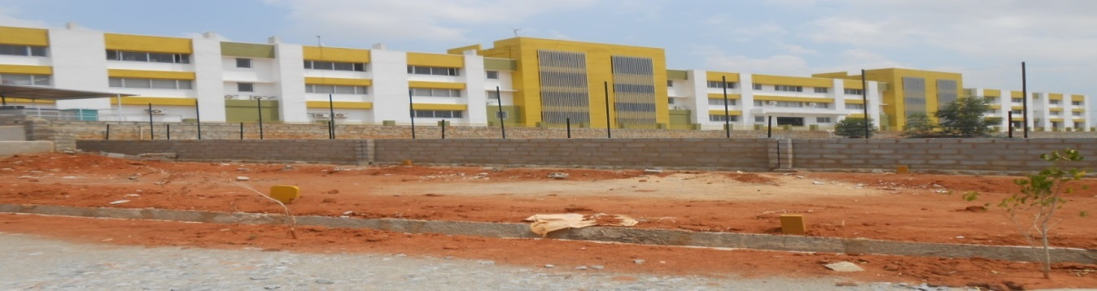
Prosperous Enclave Phase 1: Layout Depiction 1
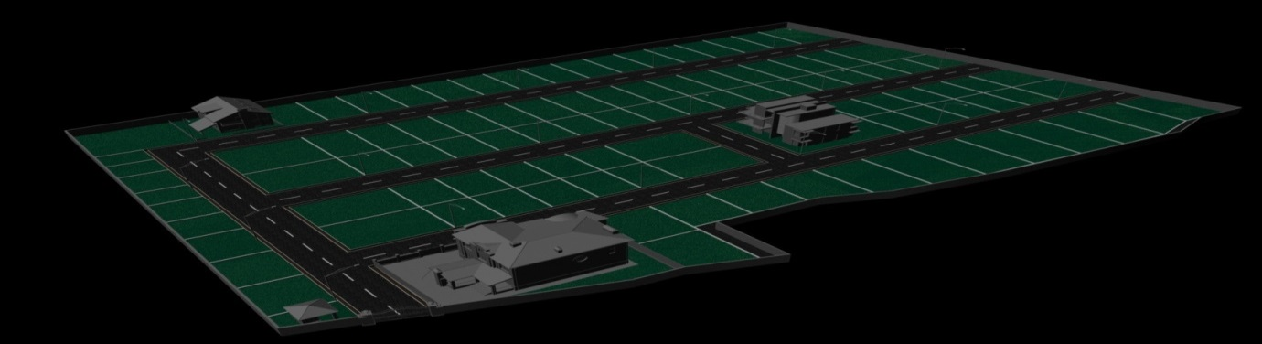
Prosperous Enclave Phase 1: Entrance to Layout
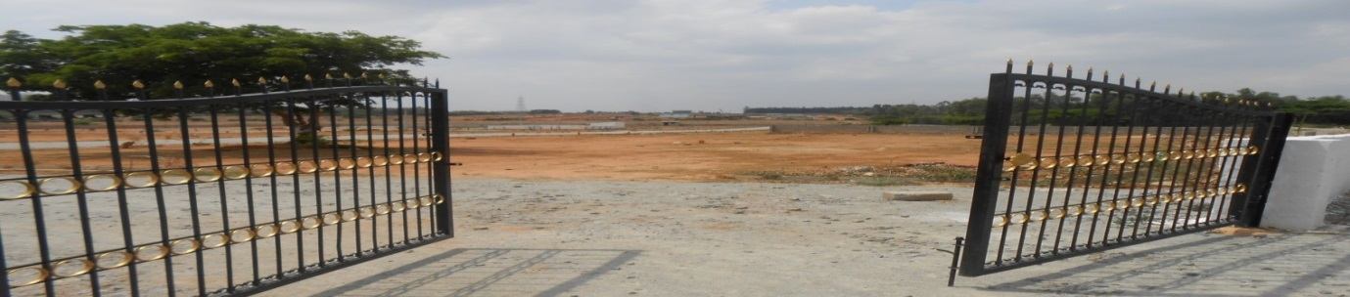
Prosperous Enclave Phase 1: Layout View 1
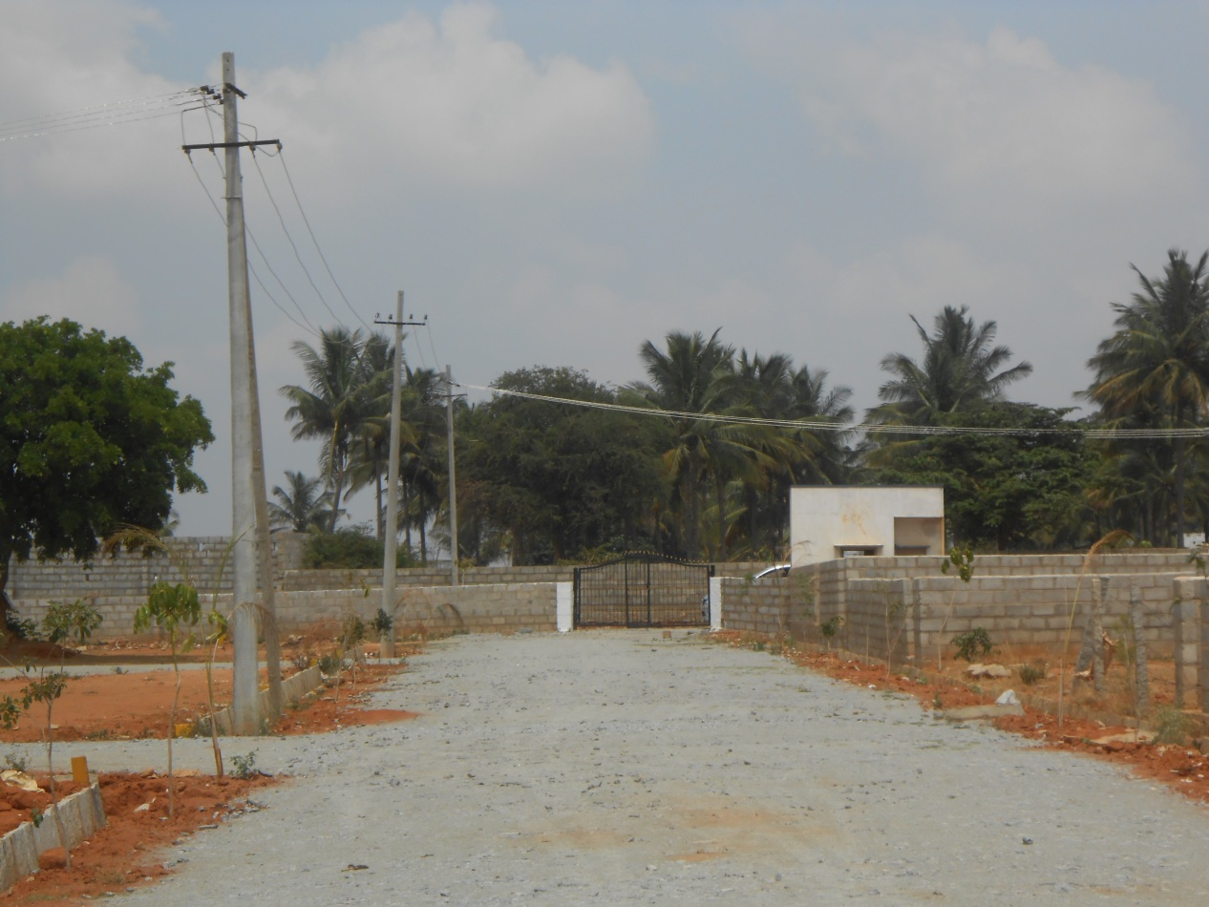
Prosperous Enclave Phase 1: Construction Besides the Layout

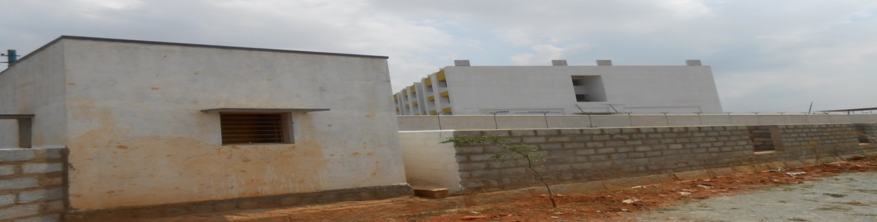

LAASYA LAKEVIEW
LAASYA LAKEVIEW (BBMP A KHATHA) LAYOUT: ELECTRONIC CITY, BANGALORE
OVERVIEW
Laasya Lake View Project, a BBMP A Khatha layout with its close proximity to Electronics City, the IT Hub of Bangalore, makes it a perfect buy to be a part of the happening city. The green canopied layout with its landscaped parks, avenue tree lining and broad streets create a refreshing retreat leaving behind the stressful city lifestyle. The refreshingly lush and beautiful locale which is within easy reach of Bangalore city is situated behind Wipro company.
Laasya Lakeview: Location Highlights
- 1.5 Kms from Electronis City.
- Close to Wipro, Infosys and other major Companies.
- 5 Kms from Silk Board and Madivala.
- Walkable distance from Hosa Road circle off Hosur Road.
- 10 minutes drive from Sarjapur Road.
- Surrounded by many International schools.
- Amidst upcoming townships.
Layout Plan
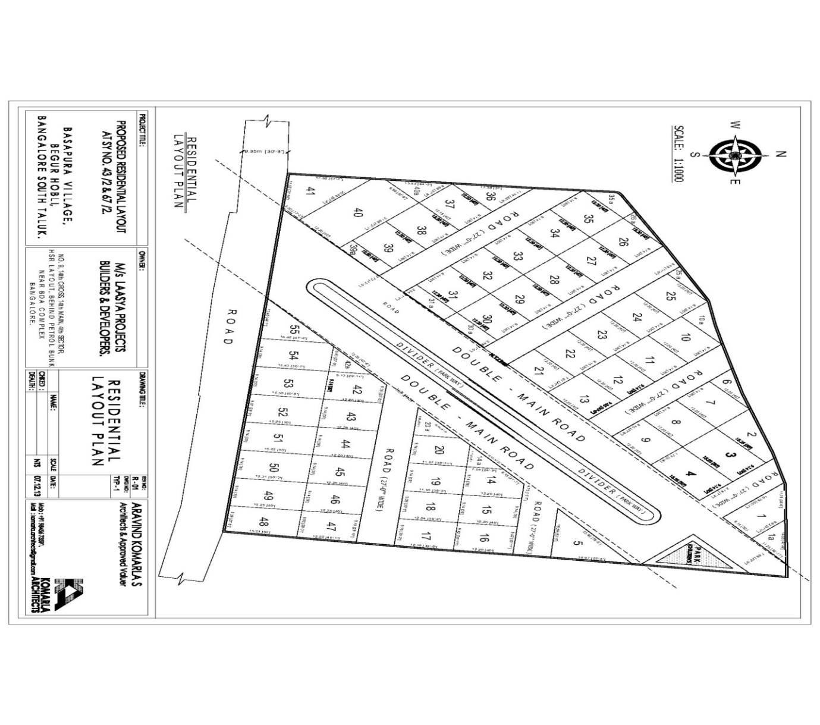
Availability
- Plot No 1 (1330 Sq Ft) to be purchased with 1 A ( 583 Sq Ft)
Plot 3 (1500 Sq Ft) to be purchased along with Plot 2 ( 984 Sq Ft) or only plot 2.
- Plot 7(1200 Sq Ft) to be purchased along with Plot 6 ( 468 Sq Ft) or only plot 6.
- Plot 10(1200 Sq Ft) to be purchased along with Plot 10A (521Sq Ft) or only Plot 10A.
- Plot No 30 A (424 Sq Ft)
- Plot No 36 ( 808 sq Ft)
- Plot No 39 A (495 sq Ft)
- Plot 40 (2879 Sq Ft) along with Plot 40A ( 546 Sq Ft).
- Plot No 41 ( 1673 Sq ft)
Plot No 5 (1487 Sq Ft)
Plot 14 (1090 Sq Ft) to be purchased along with Plot 14A ( 288 Sq Ft) or only Plot 14A.
- Plot 20 (1139 Sq Ft) to be purchased along with Plot 20A ( 465 Sq Ft) or only Plot 14A.
- Plot 42 (1143 Sq Ft) along with Plot 42A ( 385 Sq Ft) or only Plot 42A.
- Plot No 49 (1500 Sq Ft) South and Road Facing

Laasya Lakeview: Hospitals Close By
- Srujana Hospital (2.3 Kms/10 Mins)
- Archana Medical (2.8 Kms/10 Mins)
- The Apollo Hospital (4.3 Kms/20 Mins)
- Ramakrishna Healthcare & Trauma Centre (4.8 Km/s 20 Mins)
- Sri Vinayaka Gen & Maternity Hosp (5 Kms/20 Mins)
- Narayana Hrudayalaya Institute Of Cardiac Science (10kms/30mins)
- Patanjali Arogyakendra (3.6 Kms/15 Mins)
- Swamy Trauma Centre & Maternity Hospital (4.4 Kms/20 Mins)
- Infosys Medical Center (5.1 Kms/20 Mins)
- Lakshmi Nursing Home (8.2 Kms/30 Mins)
- Blossom Multispecialty Clinic and Diagnostics Centre (5.2 Kms/20 Mins)
- Sparsh Hospital (7 Kms/25 Mins)
- Mazumdar Shaw Cancer Centre (10 Kms/30 Mins)
- Fortis Hospital (5 Kms/15 Mins)
Laasya Lakeview: Schools Close By
- Euro Kids (2.7 Kms/15 Mins)
- VIBGYOR HIGH ( 1 Km/5 Mins)
- Candor International School (2 Kms/10 Mins)
- Vidyarambh (2.3 Kms/15 Mins)
- St. Xaviers ( 2 Kms/10 Mins)
- Gurukula Academy (3 Kms/15 Mins)
- Crewzincrew Dance Studio (2.9 Kms/15 Mins)
- Juzzkidz Daycare and Playschool (2.7 Kms/15 Mins)
- Christ Academy ( 2 Kms/10 Mins)
- Redbridge International Academy (3.5 Kms/20 Mins)
- Sri Chaitanya International Residential School (5 Kms/20 Mins)
- Sorsfort International School (2 Kms/10 Mins)
- Ebenezer International School (5 Kms/25 Mins)
- Treamis International School (5 Kms/25 Mins
Laasya Lakeview: Malls Close By
- Total Mall ( 10 Kms/20 Mins)
- Central Mall (15 Kms/30 Mins)
- Oasis Mall(15 Kms/30 Mins)
- Forum Mall(10 Kms/20 Mins)
- D Mart ( 5 Kms/10 Mins)
- Meenakshi Mall ( 7 Kms/20 Mins)
- Gopalan Mall ( 7 Kms/20 Mins)
Laasya Lakeview: Temples Close By
- Sri Shirdi Sai Baba Temple (10 Kms/45 Mins)
- Sri Shirdi Sai Baba Temple (10 Kms/45 Mins)
- Sri Jagannath Temple (10 Kms/45 Mins)
- Sri Shirdi Saibaba Mutt (10 Kms/45 Mins)
- Sri Hari Vaikunta Kshetra Trust (10 Kms/45 Mins)
- Varasidhi Vinayaka Temple (10 Kms/45 Mins)
- Sri Shirdi Sai Baba Temple (10 Kms/45 Mins)
- Sri Ayyappan Temple (10 Kms/45 Mins)
Laasya Lakeview: Amenities and Facilities
- Round the clock security.
- All round compound wall.
- Electricity and Water supply.
- Street Lights.
- Storm water drainage.
- Underground Sewerage.
- Asphalted road.
- Kids play area.
- Landscaped Walking Track.
- Tree Lined Roads.
Laasya Lakeview: Area & Cost
Type | Size (Ft) | Area (Sq Ft) | Facing | Rate Per Sq Ft | Cost
Plot | 30 x 40 | 1200 | North East & South | Rs 2800 | 33.60 Lakhs
Plot | 30 x 50 | 1500 | North East & South | Rs 2800 | 42 Lakhs
Plot |  | Approx 2800 | East | Rs 2800
Laasya Lakeview: Payment Plan
- On booking: Rs. 25,000/-
- On Agreement within in the next 07 days: 30%
- On registration within next 15 days: Balance amount.
Laasya Lakeview: Site Loan - Available from all leading Nationalized and Private Banks.

